Project 7/8
Corné Noorlander (1054564)
Sandra Hekkelman &
Wouter Volders
First opportunity
12/06/2026

Line detection research
Contents
Glossary 2
Executive Summary 3
Introduction 4
Theoretical Framework 5
Lane detection 5
Why lane detection is important in autonomous driving. 5
Methods 6
Results 7
Traditional detection using Hough lines 7
Segmentation approach 7
Anchor-based approach 8
Parameter-based approach 9
Transformer based approach 10
Conclusions / Recommendations 11
References (Bibliography) 12

Glossary
Lane Detection
The process of identifying lane markings on a road using computer vision or machine learning techniques.
Hough Transform
A classical computer vision technique used to detect straight lines by transforming image points into a parameter space.
Segmentation
A deep learning method that classifies each pixel in an image into a category, such as road, lane marking, or background.
Anchor-Based Detection
A method where predefined reference points (anchors) are used to predict lane positions relative to those anchors.
Parameter-Based Detection
A lane detection method where lanes are represented using mathematical functions (e.g., polynomials) instead of pixel coordinates.
Transformer-Based Model
A neural network architecture that uses attention mechanisms to model relationships between different parts of an image.
FPS (Frames Per Second)
A measure of how many frames a system can process per second, indicating real-time performance.
Hardware Constraints
Limitations in sensors, cameras and placement of these components on the Self Driving Challenge kart.

Executive Summary
The RDW wants insights into autonomous vehicles, so they set up the Self Driving Challenge for universities and HBO studies to participate. This challenge consists of multiple smaller challenges, one of them being to not concede any of the white lines. With other words, don’t leave your own lane unless the traffic situation expects this from you. In order to overcome this challenge, the lanes around the kart need to be detected.
There are multiple ways to detect lanes, these being: through Hough lines, using the segmentation approach, using the anchor-based approach, using the parameter-based approach, or using the transformer-based enhancement. In this paper, all the above-mentioned ways are researched purely theoretically.
Based on the findings, the anchor-based approach was chosen as the best fit. This conclusion is formed because of its high accuracy even on a high frame rate.

Introduction
With the rise of automation also comes the rise of autonomous vehicles. As safety tester for all vehicles built for public roads in the Netherlands, the RDW needs some insights in how those vehicles think. To get these insights, the RDW started a challenge for universities and HBO studies to participate in to program a kart, made by the RDW, to drive autonomously on their test track. This challenge is called the Self Driving Challenge’s closed category. In this challenge, the RDW provides a kart with cameras and a sensor for the teams to use. The challenge to the teams is to make this kart complete the RDW’s track by overcoming challenges, without altering the provided hardware. One of these challenges, also the most important one, is staying within the white lines. Besides staying between the white lines, the kart also needs to be able to switch lanes when theirs is ending, or if it is blocked by a stationary vehicle.
To stay within the white lines painted on the track, the kart needs to be able to see these lines and process its own position in relative to the lines. In other words, the kart needs to detect the lane it is on to know where it is positioned on it. Also, the kart needs to detect the lanes beside it so it can merge if theirs is ending or if they need to overtake the stationary vehicle.
This research was done to find the possible ways of lane detection and what the most efficient one is. This while factoring in the fact that the hardware may not be altered. Therefore, the following research question was formed: What way of lane detection is the most efficiently applicable to the closed category of the RDW’s Self Driving Challenge, keeping in mind the hardware restrictions?

Theoretical Framework

Lane detection
The term ‘lane detection’, in autonomous driving, is used to describe the vehicle processing live video feed to know where there are road lanes. In other words, the vehicle has a camera which provides live imagery of its surroundings, mostly what’s in front. This feed then needs to be processed to know where the lines confining each lane are. When this data is processed, the vehicle knows where it is allowed to drive.

Why lane detection is important in autonomous driving.
Lane detection is very important for autonomous driving because it keeps the roads organised. To further explain this, currently most of the cars on the road are operated by humans. This means roads need rules to prevent accidents and keep the roads organised. To safely get autonomous vehicles on the road, they also need to keep between these confinements. If autonomous vehicles don’t implement this, it could cause very dangerous scenarios for the other drivers to react to.
A second reason for autonomous vehicles to have lane detection is because the flow of the road is followed by the lanes. In other words, without lane detection an autonomous vehicle would not know it if the road had a sudden curve to it and would proceed straight on. This would result in the vehicle getting of the road and hitting something like a tree, a safety rail, a building or maybe even a pedestrian. This means lane detection is necessary for autonomous vehicles to stay on the road.

Methods
This research was conducted as a theoretical literature study. Due to the project being in its final iteration phase, no practical implementation or testing of lane detection algorithms was performed. Instead, the research focused on analysing existing scientific literature and technical publications to determine which lane detection method would be most suitable for future development within the RDW Self Driving Challenge (SDC) closed category.
Relevant research papers, technical articles, and comparative studies on lane detection were consulted. The methods investigated were traditional Hough line detection, segmentation-based detection, anchor-based detection, parameter-based detection, and transformer-based approaches. These methods were compared based on factors relevant to the SDC closed category, including computational requirements, detection accuracy, real-time performance, hardware compatibility, and suitability for implementation using the available front-facing camera system.
The collected information was analysed qualitatively. No experiments or measurements were conducted. Based on the findings from the literature, a recommendation was formulated regarding the lane detection approach that offers the most suitable balance between performance and computational efficiency for the hardware restrictions of the SDC.

Results
In this research the following 5 different lane detection methods will be explained:
- Traditional detection using Hough lines
- Segmentation approach
- Anchor based approach
- Parameter based approach
- Transformer based approach
The Hough lines method is based on a mathematical approach to detecting lines and lanes, while the following three are all deep learning algorithms. Lastly the Transformer approach, this is not a stand-alone approach, but rather a supportive algorithm.

Traditional detection using Hough lines
Hough lines are a way of finding lines in an image. This is relevant because a video is basically a lot of images shown one after the other.
The Hough line transform works by grey scaling, blurring the image, detecting its edges using an edge detector, and then for every white pixel for the edge detection applying the function
ρ = x * cosθ + y * sinθ. [1] Doing this will grant you the begin and end coordinates of each edge.
Because it is so ‘basic’, Hough transform comes with some down sights. Hough transform is very sensitive to environmental variables such as shadows. Shadows could make for fake edges; glare from the sun saturates the image, giving the grey scaling a different output; faded markings could produce weak gradients, potentially being blurred out as noise; vehicles occlude entire lane segments. [2] This makes the Hough line transform weak and inaccurate when compared to the three deep learning methods.
This method is applicable with the SDC hardware restrictions as it is the method used on the current iteration of this project.

Segmentation approach
As the name suggest, the segmentation approach breaks the road into segments using the view ahead.
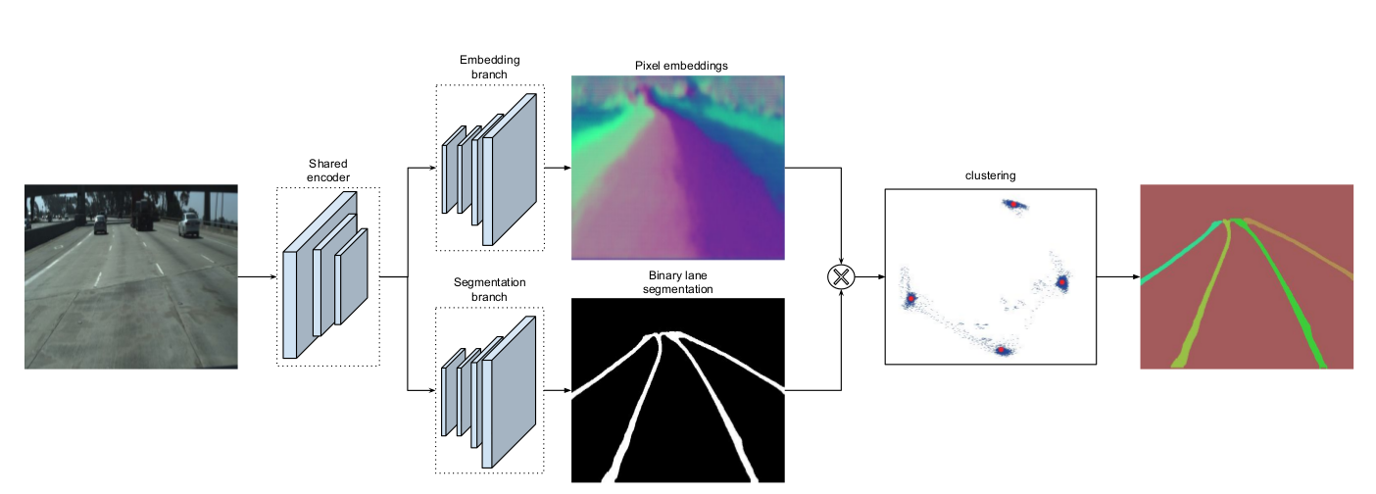
As shown in the image above, the segmentation method does two things at the same time. First, it colours each segment a different colour. In the meantime, it draws each line out. When both are done, they are combined. This gives back an image showing all the lines and distinguishing them using different colours. Something else the segmentation approach can do is differentiate between solid and dashed lines, or curved roads and straight roads. [3]
To use this approach, multiple architectures can be used. First, there is LaneNet, this is the first architecture made for this approach. Then there is SCNN, which improves the continuity of the lines compared to LaneNet. A third option is RESA; RESA has a robust lane prediction mechanism. Lastly there is CurveLane-NAS, what this does is adapt itself to the environment to optimise itself for the situation. [3]
A downside to this approach is the fact that it checks every pixel individually instead of grouping them and then checking. This makes it slower and run on only a few fps. [3]
As said before, the segmentation approach works using a front facing camera. This is mounted on the kart of the SDC closed category. This makes the segmentation approach applicable to the Self Driving Challenge closed category.

Anchor-based approach
The anchor-based approach works quite similar to object detection. It starts by placing boxes on places where there might be a line. These boxes are comparable to the ones usually seen on object detection programs. To place these boxes, the algorithm uses attention. This looks for ‘logical’ places for lines and thus avoids the sky or other regions where there won’t be any lane lines. Now that the possible places of a lane line have been narrowed down, for each box the deviation will be calculated. A second thing that happens in step two is classification. This means the line will get labelled dashed, or solid for example. Finally in step three the probabilities of all the previously calculated lines will be compared, and the highest ones will be kept leaving only a few lines on screen. [3]
Just like the Segmentation approach, the anchor-based approach has multiple algorithms that can be used. These include the following: Line-CNN, LaneAtt, SGNet, and CondLaneNet.
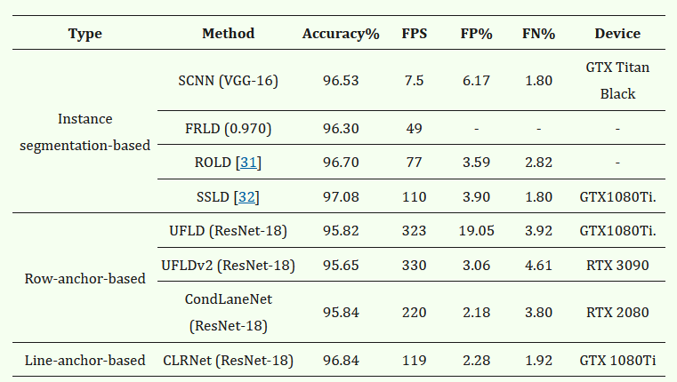
As seen in the table above [4], anchor-based algorithms are slightly less accurate, but can handle a way higher fps. This means anchor-based algorithms are quite a bit faster than segmentation-based ones all while they are only about a singular percent off in accuracy.

Parameter-based approach
Instead of predicting on pixel-level, the parameter-based approach represents lanes as mathematical curves. [2] To further explain this, the parameter-based approach interprets the lane as a line. In early math a line is defined as y = a * x + b, a and b are the values that determine the slope and offset of the line. For curved lines second grade functions are made using y = a * x^2 + b * x + c, once again a, b, and c determine the line. The parameter-based approach uses the cubic formula:
y = a * x^3 + b * x^2 + c * x + d, here a, b, c, and d define what the line looks like. This formula is used as it can define more complex curves compared to the quadratic formula. [3]
To compare this to the other deep learning algorithms, the attention needs to move to the output. A segmentation- or anchor-based algorithm returns al the pixels of the lane, while the parameter-based algorithms return, like the name suggests, parameters used to define the line. [3]
Just like the previous mentioned algorithms, the parameter-based approach makes use of a front facing camera. [5] This makes it applicable with the hardware restrictions of the SDC.

Transformer based approach
“Transformer-based lane detection refers to the neural network architecture used for feature extraction and reasoning, whereas parameter-based, anchor-based, and segmentation-based methods refer to the lane representation employed by the detector. Consequently, transformer architectures can be combined with different lane representations, including parameterized lane-shape models and anchor-based representations.” [6] To clarify this, Transformer algorithms are used to ‘simplify’ the other approaches. For attention-free methods it helps eliminate post-processing procedures, while for attention-based methods it helps with line segment detection. [7]
Since the transformer-based approach is a supportive approach, it complies with the hardware restriction set by the SDC closed category.

Conclusions / Recommendations
Based on the analysed lane detection methods, the anchor-based approach is the most efficiently applicable solution for the RDW Self Driving Challenge closed category. While segmentation-based methods generally achieve the highest accuracy, they require considerably more computational resources and operate at lower frame rates. Traditional Hough line detection is computationally inexpensive but performs poorly under realistic driving conditions such as shadows, glare, faded lane markings, and occlusions. Parameter-based methods offer an efficient representation of lane geometry, but the used research did not demonstrate a clear advantage over anchor-based methods in terms of the balance between speed and accuracy. Anchor-based methods provide near-segmentation-level accuracy while maintaining significantly higher frame rates, making them better suited for the hardware restrictions of the Self Driving Challeng. Therefore, the anchor-based approach offers the best balance between detection performance and computational efficiency and is consequently the most suitable lane detection method for the closed category.

References (Bibliography)
[1] T. Kacmajor, “Hough Lines Transform Explained,” Medium, Apr. 16, 2020. https://medium.com/@tomasz.kacmajor/hough-lines-transform-explained-645feda072ab
[2] Karyna Naminas, “Lane Detection: How It Works in Autonomous Driving Systems,” Labelyourdata.com, 2026. https://labelyourdata.com/articles/lane-detection (accessed Jun. 18, 2026).
[3] “Lane Detection: The 3 types of Deep Learning (non-OpenCV) algorithms,” Welcome to The Library!, Oct. 09, 2023. https://www.thinkautonomous.ai/blog/lane-detection/
[4] Y. Chai, S. Wang, and Z. Zhang, “A Fast and Accurate Lane Detection Method Based on Row Anchor and Transformer Structure,” Sensors, vol. 24, no. 7, pp. 2116–2116, Mar. 2024, doi: https://doi.org/10.3390/s24072116.
[5] C. Y. Kuo, Y. R. Lu, and S. M. Yang, “On the Image Sensor Processing for Lane Detection and Control in Vehicle Lane Keeping Systems,” Sensors, vol. 19, no. 7, p. 1665, Apr. 2019, doi: https://doi.org/10.3390/s19071665.
[6] R. Liu, Z. Yuan, T. Liu, and Z. Xiong, “End-to-end Lane Shape Prediction with Transformers,” arXiv.org, 2020. https://arxiv.org/abs/2011.04233 (accessed Jun. 18, 2026).
[7] J. Han et al., “Laneformer: Object-Aware Row-Column Transformers for Lane Detection,” vol. 36, no. 1, pp. 799–807, Jun. 2022, doi: https://doi.org/10.1609/aaai.v36i1.19961.
‌

